**View Controllers:**

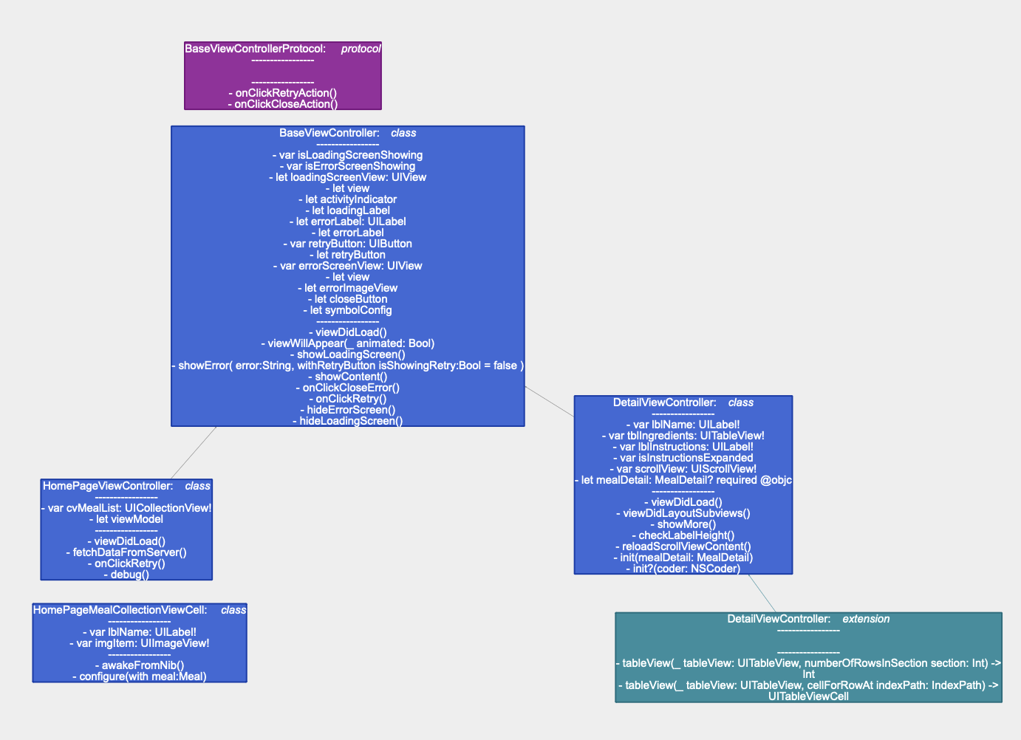

**View Modal**

**Modal Classes**

Interface Object server response

**Network:**

**XCTestCase**

**Architecture**

<--- Tightly coupled --🡪

<--- Loosly coupled --🡪

--- tightly coupled --🡪

< --- Loosly coupled ----

**View Controllers**

**XIB**

**Internet connections**

**View Model**

**Modal**